**Software Testing Assignment**

* **Module–1(Fundamental)**

**1. What is SDLC?**

* Software Development Life Cycle (SDLC) is a process used by the software industry to design, develop, and test high quality software.

**2. What is agile methodology?**

* Agile SDLC model is a combination of iterative and incremental process models.

**3. What is SRS?**

* Software Requirement Specification (SRS) is a complete description of the behaviour of the system to be developed.

**4. What is oops?**

* Object oriented programming (OOP) is a technique to design a program using different classes and object.

**5. Write basic concepts of oops**

* Object Oriented Programming has six basic concepts:

1) Object

2) Class

3) Encapsulation

4) Abstraction

5) Inheritance

6) Polymorphism

**6. What is object?**

* A thing that has identity, state, and behaviour

**7. What is class?**

* Class is a user define datatype, which is declared by the help of keyword “class”.

**8. What is encapsulation?**

* Encapsulation refers to the bundling of data, along with the methods that operate on that data, into a single unit.

**9. What is inheritance?**

* It is the capability of one class to inherit properties from another class.

**10. What is polymorphism?**

* An operation may exhibit different behaviours in different instances

**11. What is RDBMS?**

* The software used to store, manage, query, and retrieve data stored in a relational database is called a relational database management system (RDBMS).

**12. What is SQL?**

* SQL is a domain-specific language used in programming and designed for managing data held in relational database management system.

**13. Write SQL commands**

* DDL - data definition language

DML- data manipulation language

DQL - data query language

DCL/TCL – data transactional control language

**14. Write SDLC phases with basic introduction.**

* SDLC phases: -1) Requirement Gathering

2) Analysis

3) Design

4) Implementation

5) Testing

6) Maintenance

**1) Requirement Gathering**: - requirements gathering is the process of identifying your projects exact requirements from start to finish. This process occurs during the project initiation phase, but you will continue to manage your project requirements throughout the project timeline

**2) Analysis**: - The analysis phase also gathers business requirements and identifies any potential risks. This step in SDLC also includes a feasibility study, which defines all fortes and weak points of the project to assess the overall project viability.

**3) Design**: - The Design Phase is an essential phase of the Software Development Life Cycle. The list of requirements that you develop in the definition phase is used to make design choices. In the design phase, one or more designs are created to achieve the project result.

**4) Implementation**: - This phase is initiated after the system has been tested and accepted by the user. In this phase, the system is installed to support the intended business functions. System performance is compared to performance objectives established during the planning phase.

**5) Testing:** - The testing phase is where you focus on investigation and discovery. During the testing phase, developers find out whether their code and programming work according to customer requirements.

**6) Maintenance:** - The maintenance phase of the SDLC occurs after the product is in full operation. Maintenance of software can include software upgrades, repairs, and fixes of the software if it breaks. Software applications often need to be upgraded or integrated with new systems the customer deploys.

**15. Explain Phases of the waterfall model.**

* The waterfall model has 6 phases

1. Requirement Gathering
2. Analysis
3. Design
4. Implementation
5. Testing
6. Maintenance

**16. Write phases of spiral model.**

* 1) Planning

2) Design

3) Construct

4) Evaluation

**17. Write agile manifesto principles.**

* 1) Individuals and integration

2) Working software

3) Customer collaboration

4) Responding to change

**18. What is join?**

* A join is an SQL operation performed to establish a connection between two or more database tables based on matching columns, thereby creating a relationship between the tables.

**19. Write type of joins.**

* Inner join

Left join

Right join

Full join

**20. Explain working methodology of agile model and write pros and cons.**

* The Agile methodology is a way to manage a project by breaking it up into several phases. It involves constant collaboration with stakeholders and continuous improvement at every stage. Once the work begins, teams cycle through a process of planning, executing, and evaluating
* Agile sdlc model is a combination of iterative and incremental process models with focus on process adaptability and customer satisfaction by rapid delivery of working software product

**Pros**: - face to face communication with client

Frequent delivery

Easy to manage

Good model environments that change steadily

**Cons**: - maintenance problem

Less documentations

Not suitable for handling complex dependencies

**21. Draw Use case on online book shopping**

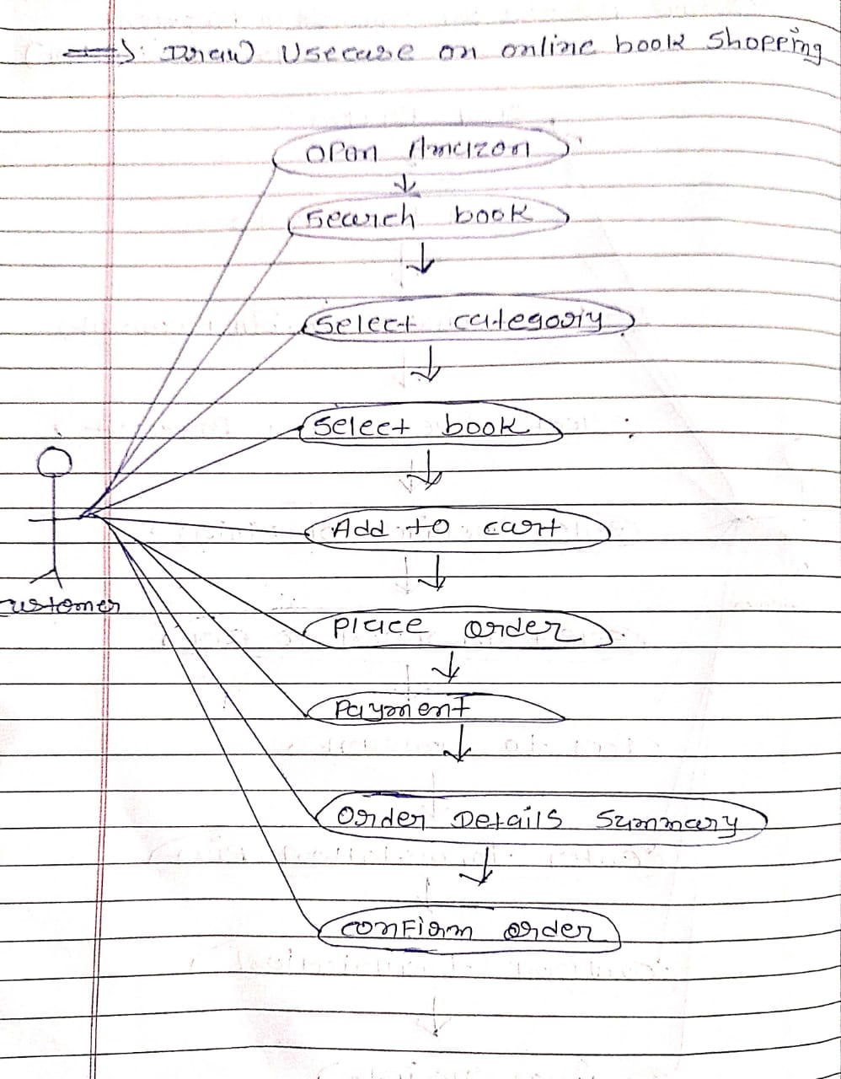

**22. Draw Use case on online bill payment system (paytm)**

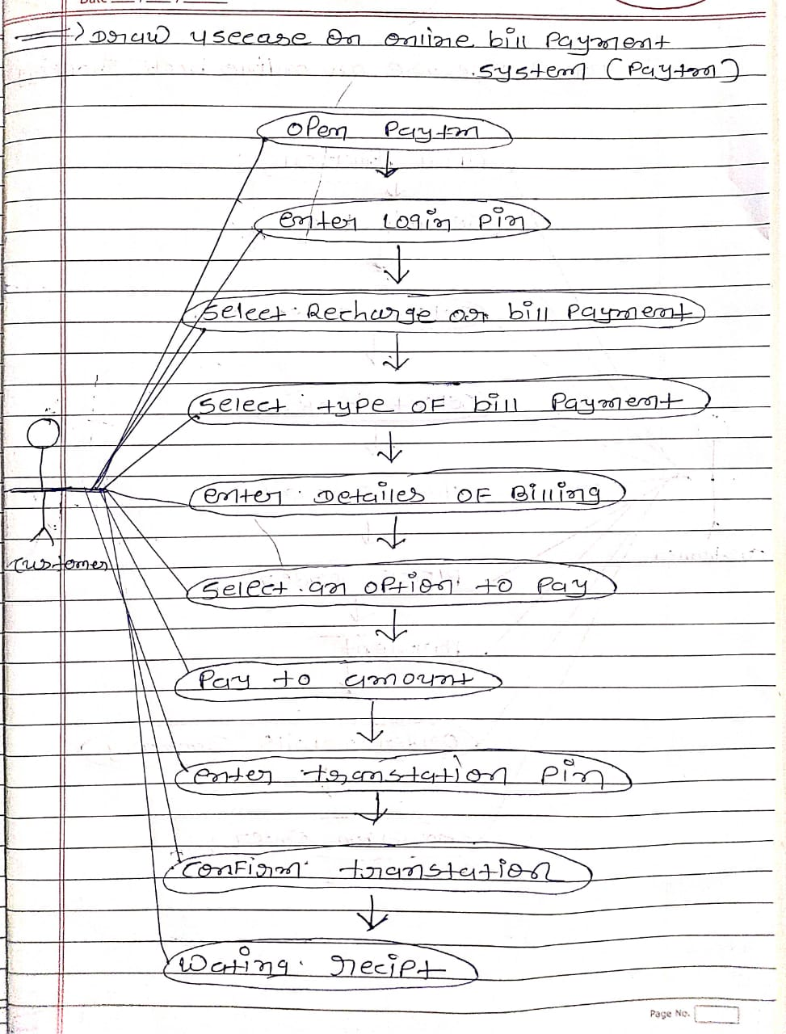

**23. Draw use case on Online shopping product using COD.**

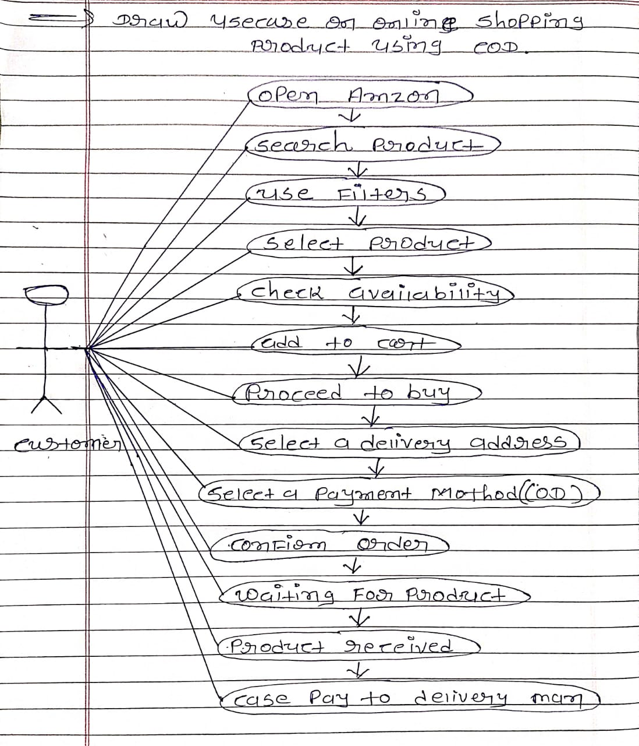

**24. Draw use case on Online shopping product using payment gateway.**

